**Associate Cloud Engineer**

Which of the following does not define a method of interacting with Google Cloud resources and services?

A. Google Cloud Console.

B. Google Cloud Terminal.

C. Google Cloud APIs.

D. Cloud Shell.

*Explanation*: The Console, SDK & Cloud Shell, and APIs are the current four methods for interacting with GCP. There is no such thing as Google Cloud Terminal.

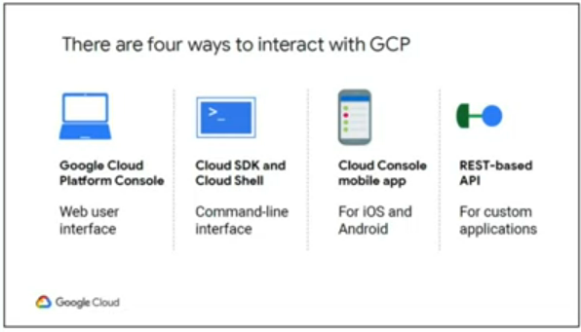

Which of the following are available on GCP as global resources that are available on GCP as global resources that are already configured? (Select two options)

A. Disk snapshots.

B. Subnets.

C. Persistent disks.

D. Disk images.

*Explanation*: Any other resource, regarless of zone or area, can access some resources. Disk snapshots and preconfigured disc images are examples of these global resources. Only resources that are located in the same region can access specific resoures.

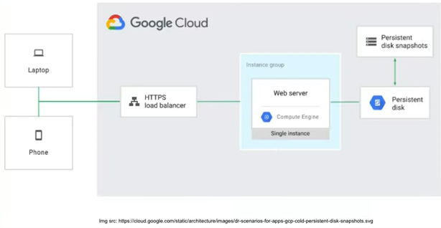

Which of the following protocols is supported as part of the GCPs cloud balancer health checks?

A. ARP.

B. SSL.

C. ICMP.

D. HTTPS.

*Explanation*: Networking services offered by Google Cloud include load balancing, routing, firewall, and network services. These services are used by google Cloud to link users’ existing networks to Google’s network, establish DNS records, and load-balance trafic between resources. In the Google Cloud Platform, the following categories and protocols are supported for load balancers:

Health Check:

HTTP and HTTPS; Legacy Health Check: gRPC, HTTP, HTTPS, HTTP/2(with TLS), SSL, and TCP.

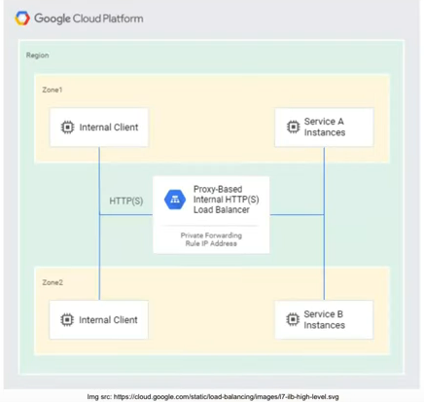

In GCP, which of the following storage services are offered?

A. Using persistent discs on Compute Engine as an instance’s primary storage

B. Large-capacity, scalable, and consistent data storage on the cloud.

C. Both A & B.

D. None of the above.

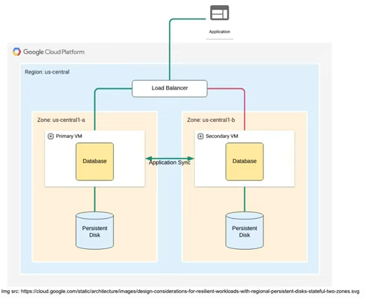

Users can select from a set of compute engine virtual machine images based on Debian 9 that are well-suited for data science and machine learning workloads using ___________.

A. Deep Learning VM Image.

B. TensorBoard.

C. Google Colab.

D. Data labeling services.

*Explanation*: Deep Learning Platform for AI You can select from a variety of compute Engine virtual machine images based on Debian 9 that are optimized for data science and machine learning workloads using VM Image. To speed up data processing trasks, all images include essential ML frameworks and tools that are ready to use rigth out of the box on instance wth GPUs.

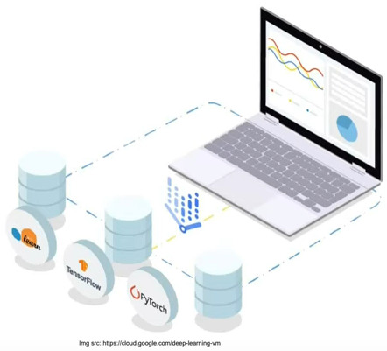

Which load balancers from the list below are supported by GCP?

A. Classic Load Balancers.

B. Server-side Load Balancer.

C. Application Load Balancers.

D. None of the above.

*Explanation*: If Compute Engine is powering your website or application, the time migth come when you’re prepared to split the workload over several instances. Network load balancing and HTTP(S) load balancing are both offered via sever-side load-balancing technologies.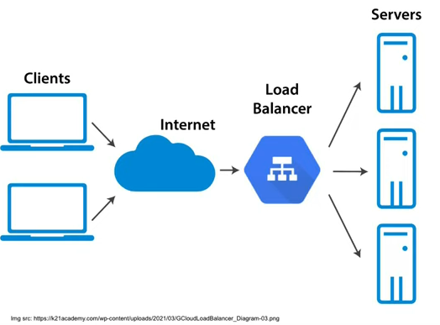

Which GCP Storage product is best for managing online content, media processing, application migrations, and data analytics?

A. Filestore.

B. Community cloud storage.

C. Firebase.

D. Cloud CDN.

*Explanation*: Consistent, scalable, large-capacity data storage is one of the many storage services offered by Google Cloud. Persistent discs are use by Google Cloud on Compute Engine as the primary storage for instance. Standart Cloud Storage, Cloud Storage Nearline, Cloud Storage Coldline, and Cloud Stoage Archive are the several types of GCP Cloud Storage. Finally, Google Cloud’s Filestore service includes fully managed NFS. file servers.

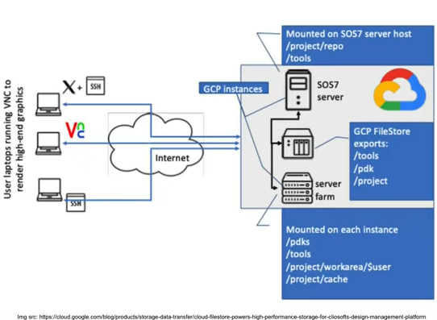

With the help of ____________, users can quickly in incorporate vision detection capabilities like picture labelling, face and landmark identification, optical character recognition (OCR), and tagging of explicit information on the GCP.

A. Panorama Necto.

B. Apache Phoenix.

C. Cloud Vision.

D. Amazon Transcribe.

*Explanation*: Cloud Vision lets you easily integrate vision detection feature, including image labeling, ace and landmark detection, optical character recognition (OCR), and taggingof explicit content. Google Cloud offers a managed service called machine learning services.

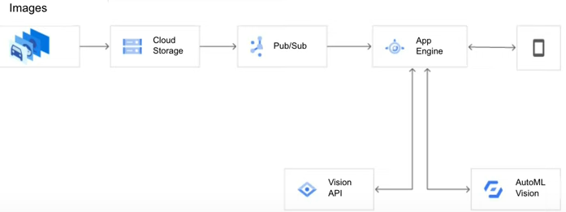

Which of the followiing flavors of GCP Cloud Storage are available?

A. Cloud Storage Nearline.

B. Cloud Storage Archive.

C. Both A & B.

D. None od the above.

*Explanation*: Persistent disks are used by Google Cloud on compute Engine as the primary storage for instances. Standard Cloud Storage, Cloud Storage Nearline, Cloud Storage Coldline, and Cloud Storage Archive are the several falvours od GCP Cloud Storage.

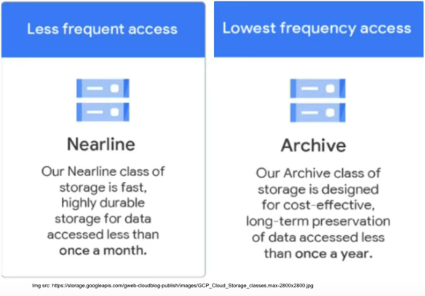

By distributing user traffic over several application instances, ________lower the possibility of some applications to become overloaded, sluggish, or unusable.

A. Azure VNets.

B. Firewall.

C. Azure Virtual Machines.

D. load balancer.

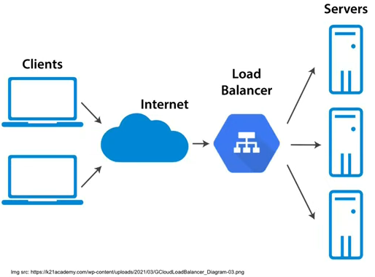

In order to create and connect cloud services, which of the following services offers a serverless execution enviroment?

A. Artificial intelligence as a Service (AIaaS).

B. Functions as a service (FaaS).

C. Backend as a Service (BaaS).

D. Containers as a Service (CaaS).

*Explanation*: In order to construct and integrate cloud services, Cloud Functions, a function as a service (Faas) solution from Google Cloud, offers a serveless execution evironment.

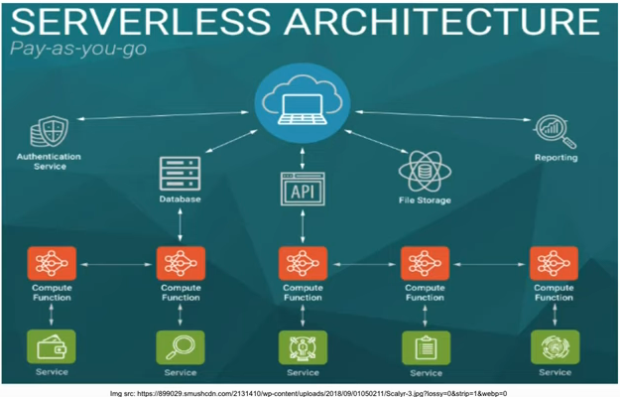

To deploy a new version of an aplication to the GCP App Engine, an administrator grants access to a another user. According to GCP best practices, which Identity Access Management (IAM) role should the administrator use?

A. App Engine Deployer

B. App Engine Creator.

C App Engine deployer.

D. Artifact Registry Administrator.

*Explanation*: All application configuration and parameters are accessible exclusively in read-only mode using App Engine Deployer.

Tou must additionally grant the Service Account User (roles/iam.serviceAccount) role in order to deploy new versions.

The Compute Storage Admin (roles/compute.storageAdmin) and cloud Buils Editor (roles/cloudbuild.builds.editor) roles must be added in order to utilise the gcloud tool for deployment.

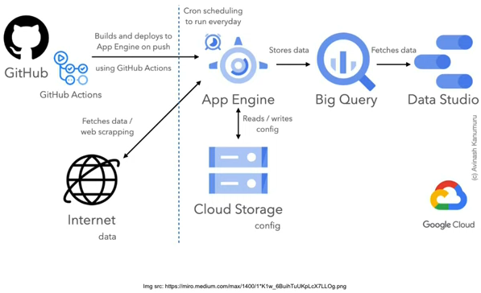

There are four roles after a project team has been established in Good Cloud Deployment Manager. Which of the following allows access to all registry resources, both read and write?

A. roles/deploymentmanager.typeEditor.

B. rolse/deploymentmanager.viewer.

C. roles/deploymentmanager.typeViewer.

D. roles/deploymentmanager.editor.

*Explanation*: The four roles are Deployment Manager Editor, Deployment Manger Type Editor, Deployment Type Viewer, and Deployment Manager Viewer once a project team has been created in Google Cloud Deployment Manager.

The Deployment Manager Type Editor, as described in the documentation, is the ideal option for giving read and write access to all Type Registry resources.

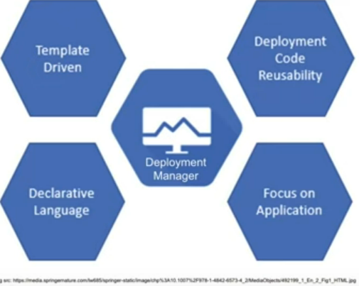

Which GCP service doesn´t fall under the Cloud Storage class?

A. Standard storage.

B. Nearline Storage.

C. Cloud Bigtable.

D. None of the above.

*Explanation*: Google offers a Big Data NoSQL database solution called cloud Bistable. Many of the main Google services, such as Search, Analytics, Maps, and Gmail, are powered by the same database. Google Cloud offers how-to manuals to assist customers in setting up and maintaining App Engine.

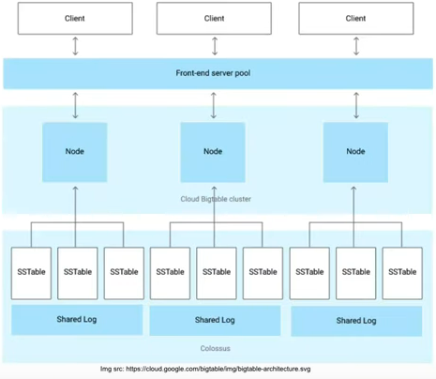

In a GCP Kubernetes cluster that currently has a two-node pool but a kubernetes app within an organisation using Google Cloud Marketplace?

A. Four

B. Five

C. One

D. Two

*Explanation*: You need to have the proper Identity and Access Management (IAM) roles or permissions for Cloud Billing, which are Viewer, Editor, Service Account Uer, and Service Account Key Admin, These four roles are needed in order to handle billing for you.

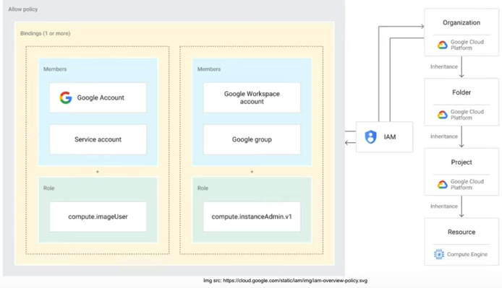

The peer device must not exceed ________ bytes when setting the maximum transmission unit (MTU) setting on a peer VPN gateway inside GCP.

A. 2048.

B. 1024.

C. 2000.

D. 1460.

*Explanation*: the peer VPN devic’s maximum transmission unit cannot be more than 1460 bytes. Pre fragmentaction must be enabled on your device so that packets can first be fragmented and then encapsulated.

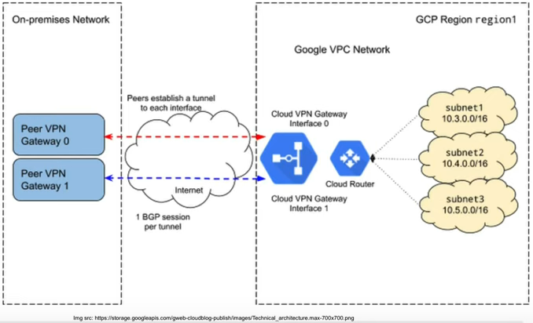

What es the bare minimum configuration needed for a virtual private network (VPN) between an external network and Google Cloud Plataform (GCP) to enable automatic update when network topology changes?

A. One Cloud VPN gateway and three Cloud Routers.

B. Three Cloud VPN gateways and two Cloud Router.

C. One Cloud VPN gateway, one Cloud Router, and one peer gateway.

D. One peer gateways and one Cloud Router.

*Explanation*: One Cloud Router is needed to advertise routes and automatically update the network topology when changes occur. Given the necessity of the extern network, just one VPN gateway and one peer gateway are required for this scenario.

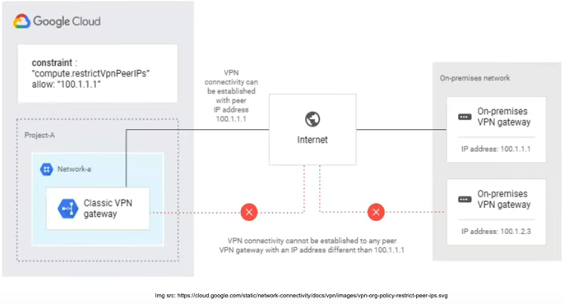

For deployment configuration files created in GCP, what file format is used?

A. YAML.

B. HDFS.

C. YARN.

D. SVG.

*Explanation*: Whenever you use one of the available methods to deploy a workload, GKE adds a configuration file to your cluster taht servers as a representation of the object. The local file and the object’s live configuration migth not match. Kubernetes objects are often created and represented using YAML.

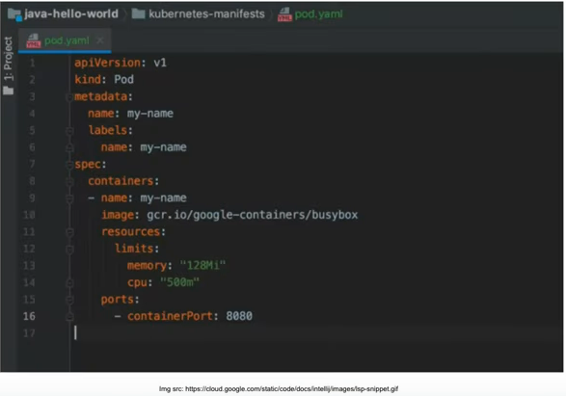

Which GCP product enables time-limited access to buckets and objects for administrators and users who don’t have Google accounts?

A. Objects Storage.

B. Signed URLs

C. Temporary Serving URLs

D. SSO

*Explanation*: A signed URL is one that offers a brief amount of time and autorization to make a request. Users without credentials can carry out particular activities on a resource using signed UTLs since they contain authentication information in their query string.

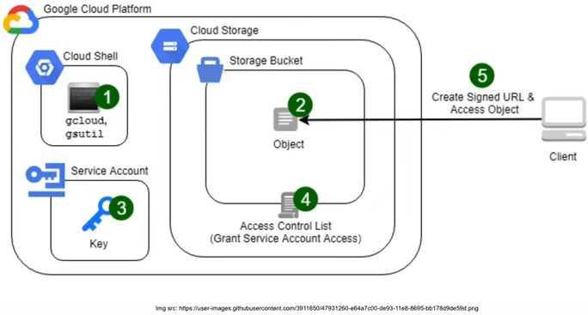

What has to be built with Stackdriver in a GCP Kubernetes cluster in order to monitor a kubernetes cluster instance?

A. Zippy Shell.

B. Seelog.

C. Workspace

D. DaemonSet.

*Explanation*: A workspace is a tool for keeping track of the resources in one or more AWS or Google Cloud projects. A Workspace can access the metrics from the projects it monitors, but the metrics are still stored in the monitored projects.

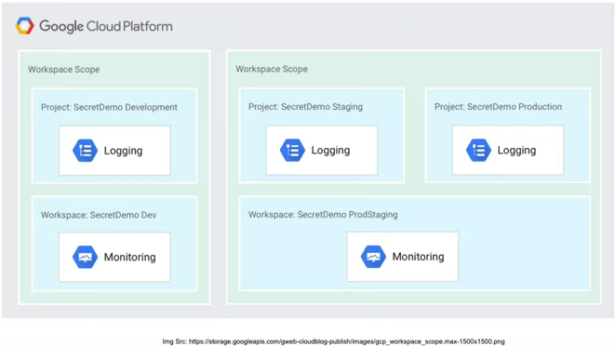

Which of the following GCP components offers Google Cloud enterprise-level services?

A. VPC Network Peering

B. Carrier Peering

C. Cloud Interconnect

D. Dedicate Peering

*Explalation*: You can select Dedicated Interconnect od Partner Interconnect if you want a higher capacity enterprise-grade connection to Google Cloud. Over Direct Peering and Carrier Peering, which you would utilise in specific situations, we advise adopting Cloud Interconnect.

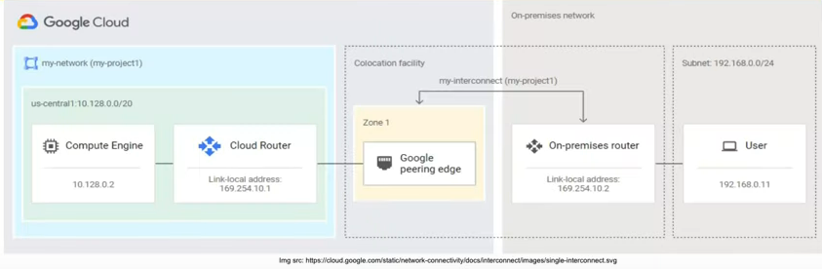

Which of the following types of gateways is supported by GCP’s high availability (HA) VPN tunnel?

A. NetMotion VPN.

B. Classic VPN Gateway.

C. HA VPN Gateway.

D. None of the above.

*Explanation*: Google Cloud offers two types of Cloud VPN gateways: HA VPN and Classic VPN.

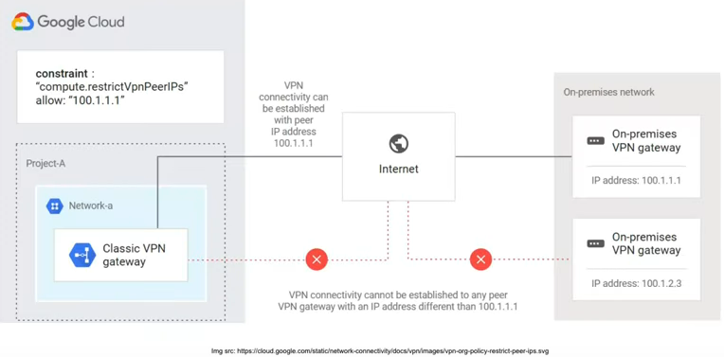

Which of the following GCP resources is connected directly through a Cloud Router interface?

A. Classic VPN tunnel.

B. An HA VPN tunnel.

C.All of the above.

D. None of the above.

*Explanation*: Before you can conduct the following, your Cloud Router must already be functional.

- Make a Dedicated Interconnect VLAN attachment.

- VLAN attachment should be created for Partner Interconnect.

- Establish a VPN connection to a HA VPN gateway.

When you crate a Cloud Router, you can choose the Google-side ASN. If you don’t specify an ASN, Google Cloud chooses an ASN for you.

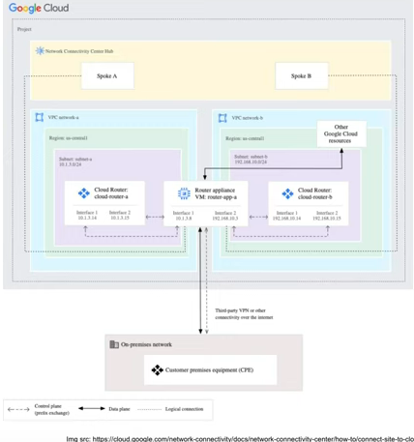

The number of interfaces you set for the external VPN gateway resource is indicated by the REDUNDANCY TYPE parameter in the GCP HA VPN API. When there are two external VPN interfaces, which of the following values is supported?

A. TWO_IPS_REDUNDANCY.

B. FOUR_IPS_REDUNDANCY.

C. SINGLE_IP_INTERNALLY_REDUNDANT.

d. SINGLE_IP_EXTERNALLY_REDUNDANT.

*Explanation*: The number of interfaces you set for the external VPN gateway resource is indicated by the REDUNDANCY TYPE parameter in the HA VPN API.

gcloud commands automatically infer the values of REDUNDANCY_TYPE from the number of intrefaces provided in the interface ID during configuring and external VPN gateway resource: Two external VPN interfaces are TWO_IPS_REDUNDANCY.

Which GCP database service requires a failover replica to be set up by the administrator in order to be highly available?

A. AlloyDB for PostgreSQL

B. Cloud Bigtable

C. Cloud SQL

D. Firestore

*Explanation*: Cloud SQL produces a regional instance when you create an instance and set it up for high availability. When creating an instance, you may set it up for high availability, or you can turn high availability on for an already-running instance.

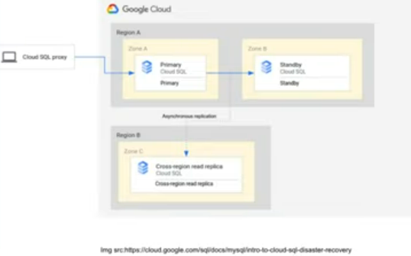

How many virtual CPUs (vCPUs) can a GCP N1 Broadwell custom virtual machine instance have?

A. 64

B. 256

C. 20

D. 34

*Explanation*: The machine type you select will decide the maximum number of virtual CPUs that may be used with a custom machine type. You can deploy custom machiine types with up to 64 vCPU for N1 machines types in zones that support the Broadwell, Haswell, or Ivy Bridge CPU platforms.

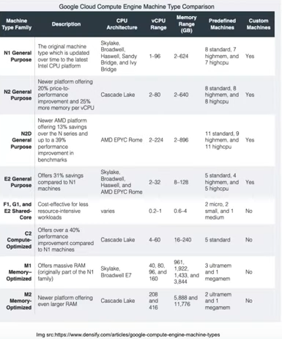

In a GCP cluster, _________ are single instances of active processes.

A. Namespaces

B. Preemptible instance

C. Machine images

D. Pods

*Explanation*: The simplest and most fundamental deployable objects in Kubernetes are called pods. In your cluster, a Pod indicates a single instance of an active process.

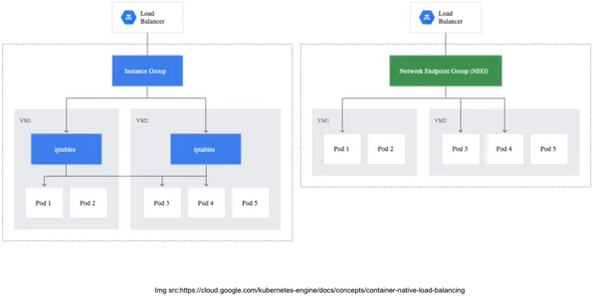

Which kubectl command in the Google Kubernetes Engine is used to launch a deployment?

A. Create.

B. Logs.

C. Run.

D. Launch.

*Explanation*: When using Google Kubernates Engine, you launch a deployment using the kubectl run command.



Which of the following protocols may be used for IP forwarding on the Google Cloud Platform Compute Engine?

A. ARP, ICMP, SCTP.

B. UDP, FTP.

C. ICMP only.

D. AH, ESP, and ICMP.

*Explanation*: Compute Engine provides protocol forwarding for the following protocols for virtual hosting by IPs, virtual private networks (VPN), and load balancing:

AH: Specifies the IP Authentication Header protocol.

ESP: Specifies the IP Encapsulating Security Payload protocol

ICMP: Specifies the Interner Control Message Protocol

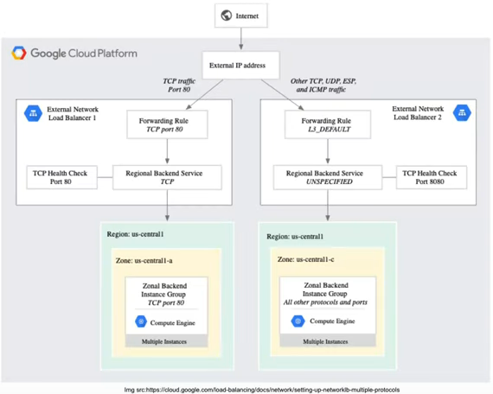

An administrator or user who is considering applicable routes and routing order can determine effective routes with the use of ____ analysis.

A. Log.

B. Workspace.

C. Route.

D. Subnet Mask.

*Explanation*: You may identify effective routes by using route analysis, taking into account suitable routes and routing order. You can tell which appropiate route will be utilized to deliver traffic to a specific destination range since routes are displayed by destination IP range.

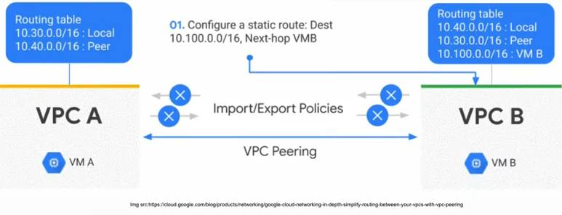

An administrator or users can benefit from the open-source data technologies for batch processing, query, streaming, and machine learning by using _____, a managed Spark and Hadoop service.

A. Dataflow.

B. Dataproc.

C. Firestore.

D. Cloud SQL.

*Explanation*: You can use open-source data technologies for batch processing, querying, streaming and machine learning with Dataproc, a managed Spark and Hadoop service. By shutting off clusters when not in use, dataproc automation enables you to easily manage clusters and save money. You can concentrate on your work and your data if spend less time and money on administration.

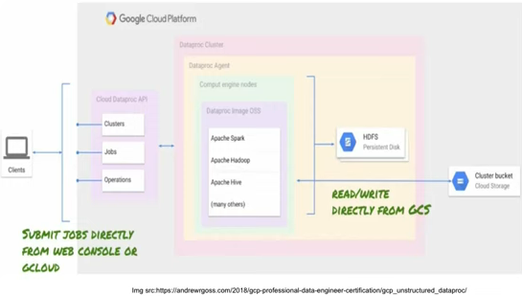

The Google Cloud Platform has a feature called _____ that enables an administrator or user to inspect the state of an application at any point in the code without pausing or slowing down the program that is already running.

A. API management.

B. Data Analytics.

C. Cloud Dataflow.

D. Cloud Debugger.

*Explanation*: The Google Cloud Platform’s Cloud Debugger feature enables you to analyze the state of an application at any points in its code without pausing or slowing it down while it is running. Without adding logging lines, it is simpler to view the application status with Cloud Debugger. It will be deprecated in 2023.

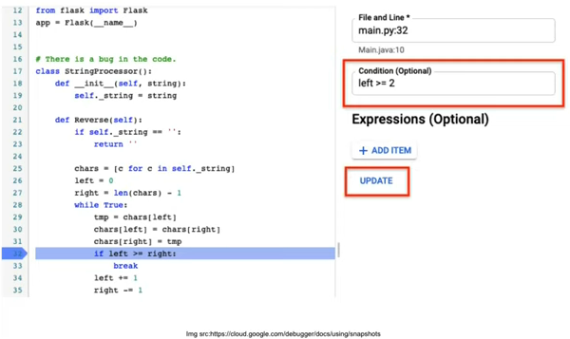

What command do you enter GCP Cloud Storage to enabled lifecycle management via the command line?

A. gsutil lifecycle set

B. gcloud compute instances

C. gcloud config set

D. gcloud lifecycle start

*Explanation*: A set rules is present in every lifecycle management setup. You may provide any set of criteria for any action when defining a rule. If a rule has many conditions, each condition must be met by an object in order for the rule to take effect. Use the gsutil lifecycle command: gsutil lifecycle set to enabled lifecycle management for a bucket through the command line.

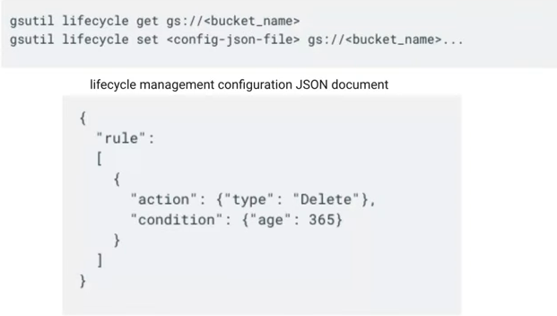

What is the command to alter the default storage class from the command line when configuring GCP Cloud Storage?

A. gsutil data set <default class>

B. gcloud config set <project-id>

C. gsutil defstorageclass set <storage class>

D. gcloud defstorage set <storage class>

*Explanation*: If you don’t provide a storage class when you upload an object to the bucket, the bucket’s default storage class is given to the object. Use the gsutil defstorageclass set command as follows: gsutil defstorageclass set STORAGE_CLASS gs://BUCKET_NAME

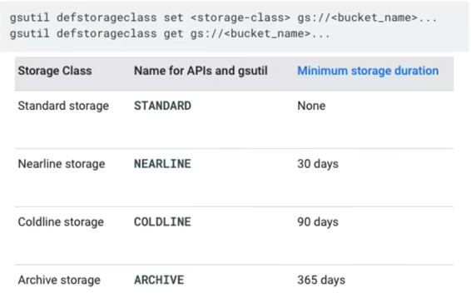

When creating a subnet, what kinds of VPC networks does GCP often offer? (Select two options)

A. Native Mode.

B. Custom Mode.

C. Auto mode

D. Datastore Mode.

*Explanation*: Depending on the subnet construction option, Google Cloud provides two different types of VPC networks: One subnet from each region is automatically formed when an auto mode VPC network is created.

When a custom mode VPC network is created, no subnet are automatically created. This type or network provides you with complete control over its subnets and IP ranges.

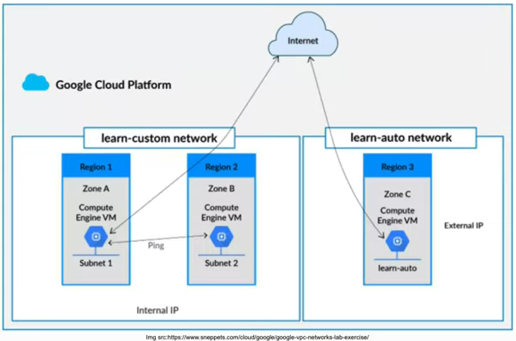

What command should you use to deploy the APP Engine app from the command line while configuring GCP App Engine?

A. gcloud app versions list

B. gcloud app deploy

C. gcloud app create

D. gcloud beta app deploy.

*Explanation*: Gcloud app deploy is the command you use to deploy the App Engine application. Use either the Maven build tool (preferred) or the gcloud app deploy command from within the root directory of your application to deploy your app to App Engine.

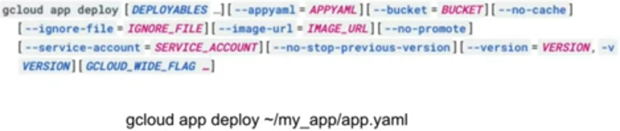

What steps can a cloud enginner take to prevent the storage od unneeded data in the datastore?

A. Create an Auto Scaling group.

B. Put index parameters at their maximum value.

C. Remove all index.

D. Delete any entities the application no longer needs.

*Explanation*: The size of the jobs in the task queue, the size of the entities in the Datastore, the size of the Datastore index, and the volume of data saved in Blobstore are taken into account for detemining App Engine’s storage costs. Entities or blobs that your application no longer requires should be deleted to ensure that you don’t keep more data than necessary.

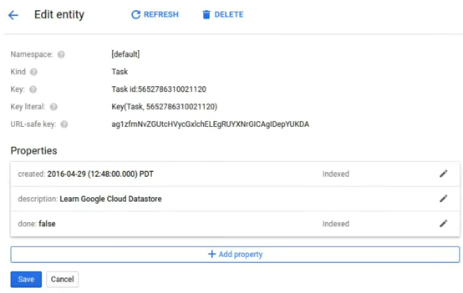

To examine the current cluster(s) in GCP, which gcloud command can be used?

A. gcloud Cluster_Name

B. gcloud container cluster List

C. gcloud clusters container Name

D. None of the above.

*Explanation*: The command to see a specific cluster in gcloud is gcloud container clusters Cluster Name, and the keyword list may be used in place of the specific cluster name to view the clusters in the default zone.



When is it advisable to scale up an instance group?

A. CPU utilization, network latency, and load-balancing capacity.

B. Disk usage only.

C. For load-balancing capacity.

D. Operating system updates only.

*Explanation*: According on CPU use, monitoring metrics, load-balancing capacity, or network latency, the autoscaling policy may be set to add or remove instances. Metrics that indicate the load and capacity of the instance group are used to determine how much to scale an autoscaling policy.

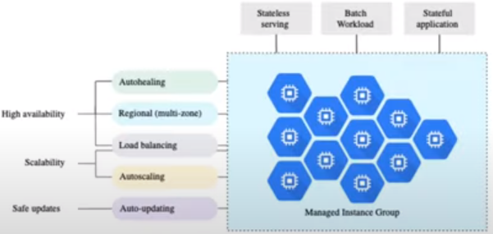

BigQuery keeps all query result in a table in GCP. The table is either a destination table that has been explicitly identified by the user or it is a temporary result table that has been cached. Which of the following restrictions applies while using the query cache?

A.Only DML commands can target cached result tables.

B.The maximum response size must be smaller than the result set.

C. You cannot target cached result tables with DML statements.

D. The text of a duplicate query must not be an exact match to the original.

*Explanation*: The result set must be less than the maximum response size in order for the query result to be stored in a cached results table.

Data manipulation languaje (DML) commands cannot target cached result tables.

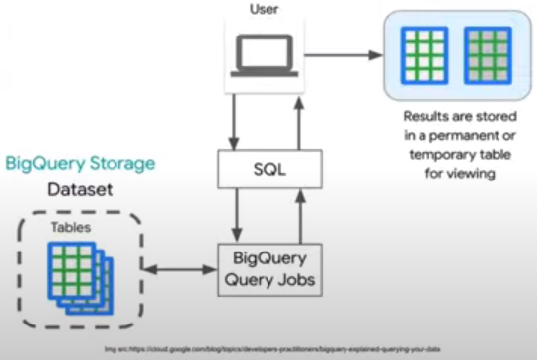

When a Goole Kubernetes cluster is delete, which of the following resources are also removed? (Select 2 options)

A. Node allocatable resources.

B. Persistent Volume.

C. Control plane resources.

D. All node instances in the cluster.

*Explanation*: When you delete a cluster, the following resources are deleted:

The control plane resources.

All of the node instance in the cluster.

Any Pods that are running on those instances.

Any firewalls and routes created by GKE at the time of creation.

Data stored in host hostPath and emptyDir volumes.

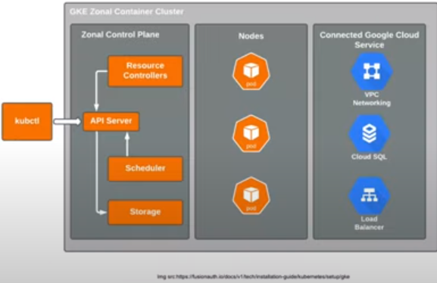

In order to create and connect cloud services, which of the following services offers a serverless execution environment?

A. Artificial Intelligence as a Service(AIaaS)

B. Functions as a service (FaaS)

C. Backend as a Service (BaaS)

D. Containers as a Service (CaaS)

*Explanation*: Cloud Functions, Google Cloud’s function as a service (FaaS) offering, provides a serveless execution environment for building and connecting cloud services.

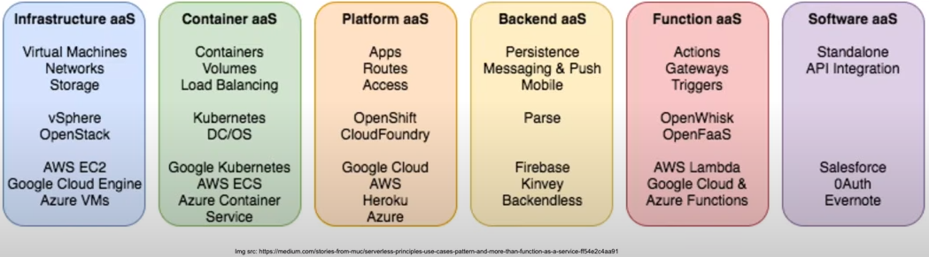

A Cloud Engineer can modify a number of settings in the _____ configuration file to alter how performance and resource load are traded off for a particular app version.

A. app.yaml

B. dispatch.yaml

C. service.yaml

D. index.yaml

*Explanation*: For a particular version of your app, you can modify a variety of settings in the app.yaml configuration file to adjust the trade-off between performance and resource load.

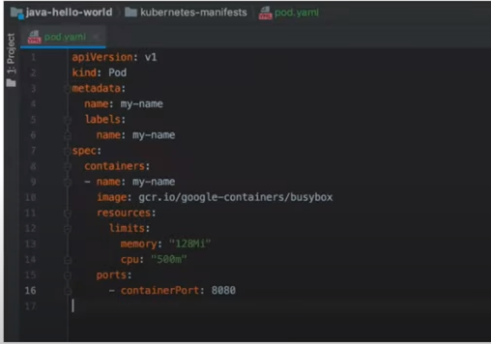

What command does an adminstrator or use on the command line to create a forwarding rule in the GCP Compute Engine VPC to redirect traffic to a single instance?

A. gcloud create compute instances

B. glcoud compute forward-rules create

C. gcloud compute target create

D. gcloud compute create compute-rules

*Explanation*: Traffic that matches the IP protocol and port is sent to a specific target instance by a forwarding rule object.

The commands that follow generate three dorwarding rules that each direct TCP traffic to your target instance using an ephemeral IP address.

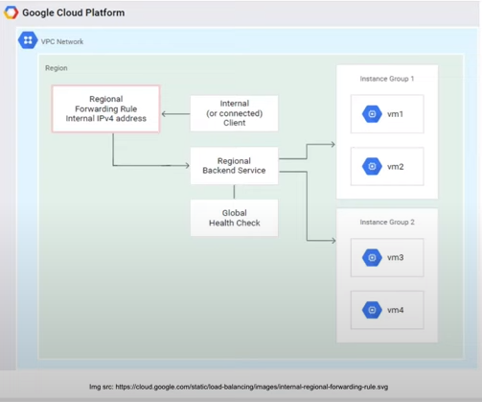

What must an administrator or user do in order to get a static internat IP address for a virtual machine in GCP? Select any two

A. By replacing it with a well-know public IP address.

B. Reserve a new static external IP address and the assign the address when creating the VM.

C. External public static IP addresses are always enabled.

D. Promote an existing ephemeral external IP address to become a static external IP address.

*Explanation*: You can et a static external IP address for a virtual machine (VM) instance if it requires a constant, fixed external IP address by using one of the following methods:

Reserve a new static external IP address and then assign the address to a new VM instance.

Promote an existing ephemeral external IP address to become a static external IP address.

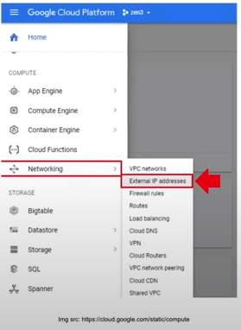

Administrators in GCP discover a poor response time while sending commands to a server when operating an instance. What command should be use to restart the machine?

A. Reset.

B. Restore.

C. Shutdown.

D. Reinstate.

*Explanation*: A GCP virtual instance can be restarted with the reset command. when you reset an instance, none of the instance proporties change, as stated in the manual. The instance keeps its machine type, persistent disc, IP address, etc. Unless you have a backup of the data, any information saved in memory is reset.

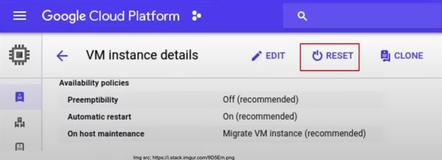

What is the term used in GCP for acting in the place of other members and resources when Identity and Access Management (IAM) is applied to an instance?

A. Auth proxy

*B. Impersonate*

C. Editor role

D. agent

*Explanation*: Allowing members and resources to act as Identity and Access Management (IAM) service account is know as impersonating. It also describers how to check out which members have impersonation rights for a specific IAM service account.

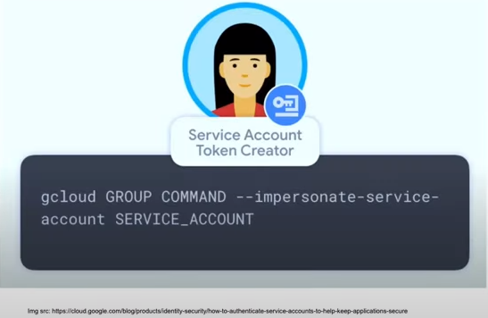

What commands should you use in GCP to obtain a list permissions that may be applied to a target resource when deploying Identity and Access Management (IAM) to an instance?

A. gcloud manager permissions

B. gcloud iam list-testable-permissions

C. gcloud iam authorizations

D. gcloud iam record permissions

*Explanation*: Permissions that a user may add or delete in a role for a specific resource are referred to as testable permissions. A URL or the complete resource name can be used to refer to the resource.

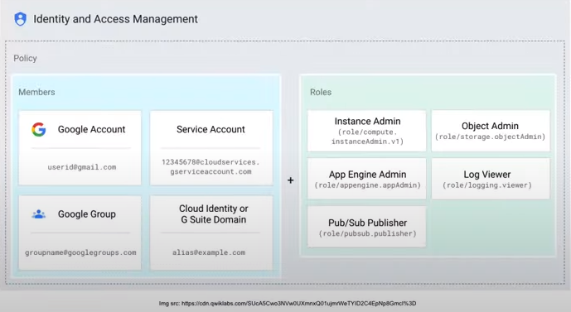

In the GCP, this kind of VPC network gives users total control over its subnets and IP ranges.

A. Automode.

B. Solid mode.

C. Preferable mode.

D. Custom mode.

*Explanation*: There are no automated subnet creations when a custom mode VPC network is built. You have total control over the subnets and IP ranges on this kind of network. With the help of IP ranges that you define, you pick which subnets to build in the areas of your choice.

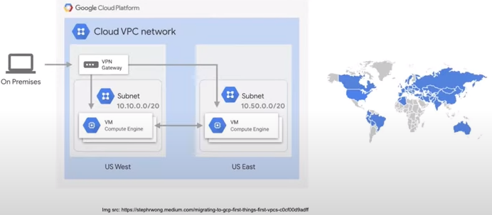

<https://www.youtube.com/watch?v=9CEJ1YYgsJk> 29:00

<https://www.youtube.com/watch?v=68iPCt1gRyI&list=PL6GprBYnITww3_aOw0agFaXGzMryGdryJ>